Sapelo Hammock Golf Academy
2019 Junior Summer Golf Camps
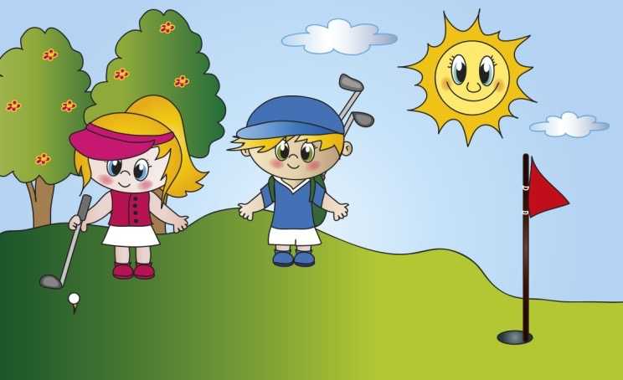
For Junior Golfers Ages 5 to 16
Session I: June 3 - 6 (Monday thru Thursday) 9:00am until noon
Session II: July 22 - 25 (Monday thru Thursday) 9:00am until noon
- - - Rain or Shine - - -
Instruction Includes: Golf Etiquette, Rules of Golf, Sportsmanship, Putting, Chipping, Pitching, Full Swing, and more.
Cost is $150/student, which includes: Golf Instruction, Drinks, Lunch, Awards.

For more information Contact:

Graham Lewis, USGTF (912) 617-3743

